Hasil
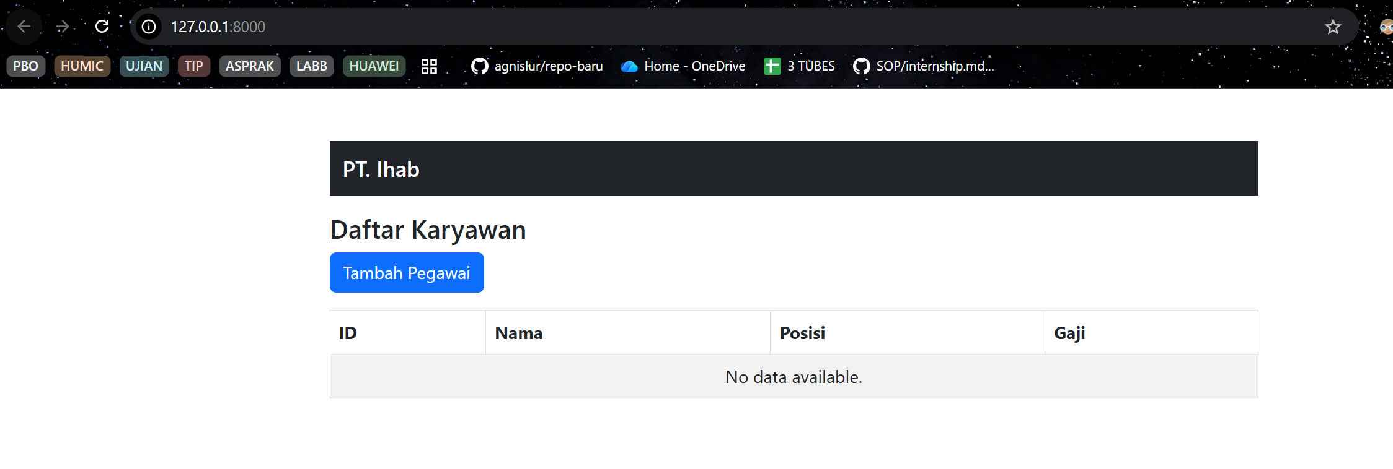
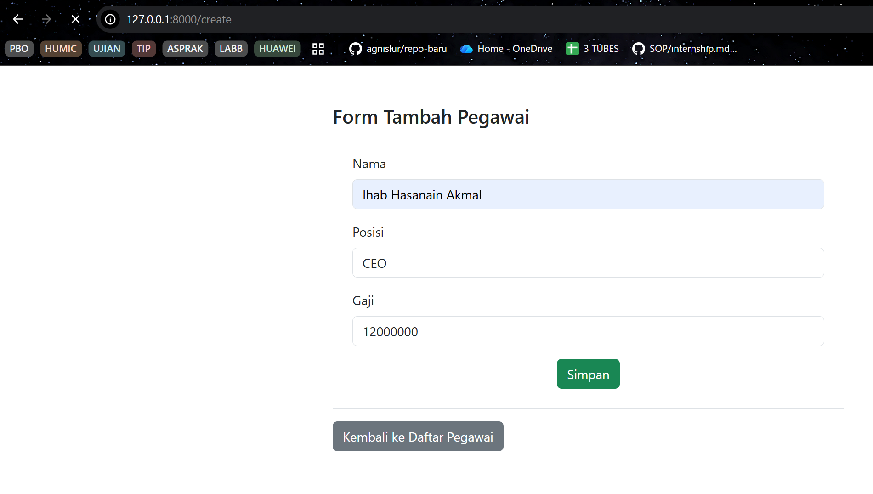
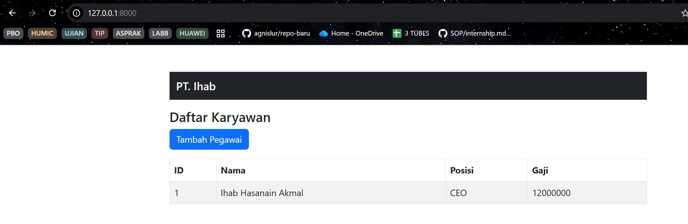
Routes
<?php

use App\Http\Controllers\PegawaiController;
use Illuminate\Support\Facades\Route;

Route::get('/', [PegawaiController::class, 'index'])->name('pegawai.index');

Route::get('/create', [PegawaiController::class, 'create'])->name('pegawai.create');

Route::post('/', [PegawaiController::class, 'store'])->name('pegawai.store');

Index
<!DOCTYPE html>
<html lang="en">
<head>
<meta charset="UTF-8">
<meta name="viewport" content="width=device-width, initial-scale=1.0">
<title>Daftar Pegawai</title>
<link href="https://cdn.jsdelivr.net/npm/bootstrap@5.3.0/dist/css/bootstrap.min.css" rel="stylesheet">
</head>
<body class="container">
<div class="row justify-content-center mt-5">
<div class="col-md-8">
<nav class="navbar navbar-dark bg-dark">
<div class="container-fluid">
<span class="navbar-brand mb-0 h1">PT. Ihab</span>
</div>
</nav>
<h4 class="mt-3">Daftar Karyawan</h4>

<a href="{{ route('pegawai.create') }}" class="btn btn-primary mb-3">Tambah Pegawai</a>

<table class="table table-bordered table-striped">
<thead>
<tr>
<th>ID</th>
<th>Nama</th>
<th>Posisi</th>
<th>Gaji</th>
</tr>
</thead>
<tbody>
@forelse ($data_pegawai as $pegawai)
<tr>
<td>{{ $pegawai->id }}</td>
<td>{{ $pegawai->nama }}</td>
<td>{{ $pegawai->posisi }}</td>
<td>{{ $pegawai->gaji }}</td>
</tr>
@empty
<tr>
<td colspan="4" class="text-center">No data available.</td>
</tr>
@endforelse
</tbody>
</table>
</div>
</div>
</body>
</html>

Form
<!DOCTYPE html>
<html lang="en">
<head>
<meta charset="UTF-8">
<meta name="viewport" content="width=device-width, initial-scale=1.0">
<title>Form Tambah Pegawai</title>
<link href="https://cdn.jsdelivr.net/npm/bootstrap@5.3.0/dist/css/bootstrap.min.css" rel="stylesheet">
</head>
<body class="container">
<div class="row justify-content-center mt-5">
<div class="col-md-6">
<h4>Form Tambah Pegawai</h4>
<form class="border p-4" method="POST" action="{{ route('pegawai.store') }}">
@csrf
<div class="mb-3">
<label for="nama" class="form-label">Nama</label>
<input type="text" name="nama" id="nama" class="form-control" value="">
</div>
<div class="mb-3">
<label for="posisi" class="form-label">Posisi</label>
<input type="text" name="posisi" id="posisi" class="form-control" value="">
</div>
<div class="mb-3">
<label for="gaji" class="form-label">Gaji</label>
<input type="number" name="gaji" id="gaji" class="form-control" value="">
</div>
<div class="text-center">
<button type="submit" class="btn btn-success">Simpan</button>
</div>
</form>
<a href="{{ route('pegawai.index') }}" class="btn btn-secondary mt-3">Kembali ke Daftar Pegawai</a>
</div>
</div>
</body>
</html>

Controller
<?php

namespace App\Http\Controllers;

use App\Models\Pegawai;
use Illuminate\Http\Request;

class PegawaiController extends Controller
{
public function index()
{
$data_pegawai = Pegawai::all();
return view('pegawai.index', compact('data_pegawai'));
}
public function store(Request $request)
{
Pegawai::create([
'nama' => $request->nama,
'posisi' => $request->posisi,
'gaji' => $request->gaji,
]);

return redirect()->route('pegawai.index')->with('success', 'Data Pegawai berhasil ditambahkan!');
}
public function create()
{
return view('pegawai.form');
}
}

Models
<?php

namespace App\Models;

use Illuminate\Database\Eloquent\Factories\HasFactory;
use Illuminate\Database\Eloquent\Model;

class Pegawai extends Model
{
use HasFactory;

protected $table = 'pegawais';
protected $primaryKey = 'id';
protected $fillable = [
'nama',
'posisi',
'gaji'
];
}

Database
<?php

use Illuminate\Database\Migrations\Migration;
use Illuminate\Database\Schema\Blueprint;
use Illuminate\Support\Facades\Schema;

return new class extends Migration
{
/**
* Run the migrations.
*/
public function up(): void
{
Schema::create('pegawais', function (Blueprint $table) {
$table->id();
$table->string('nama');
$table->string('posisi');
$table->integer('gaji');
$table->timestamps();
});
}

/**
* Reverse the migrations.
*/
public function down(): void
{
Schema::dropIfExists('pegawais');
}
};

